Exp no:11 Determination and plotting of Magnetic Flux density in Ferromagnetic Materials with different (i) length, (ii) width and (iii) magnetic field intensity.
Aim:
To write program for Magnetic flux density in ferromagnetic materials using SCILAB.
Software required:
•SCILAB version 6.0.1
Code:
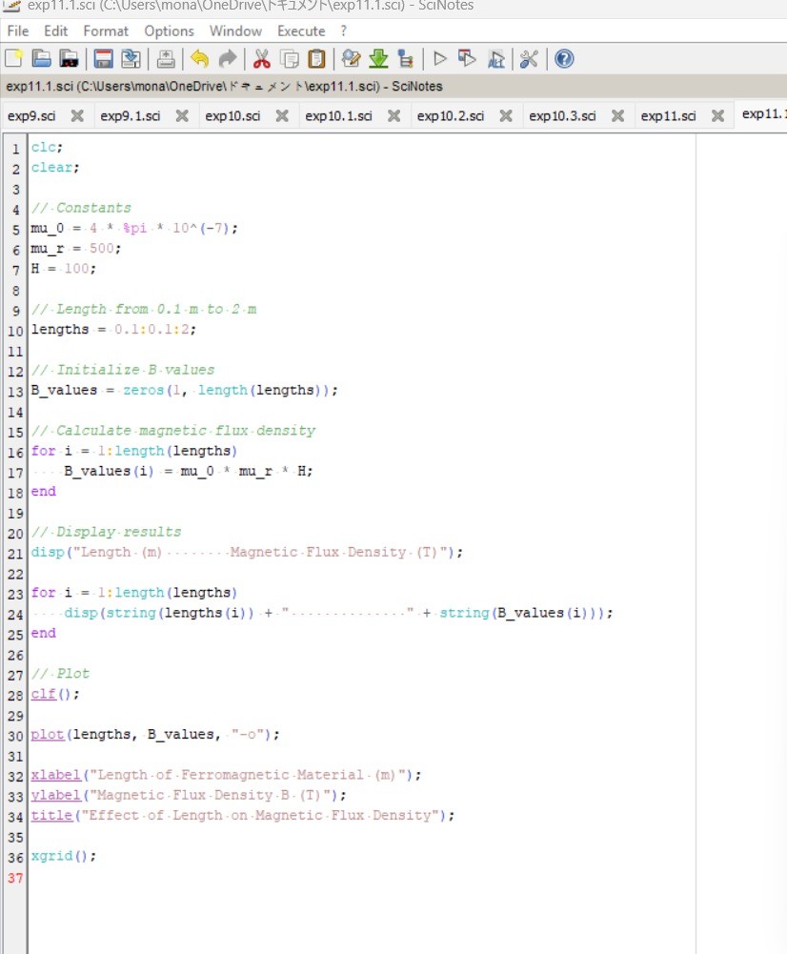
Output:
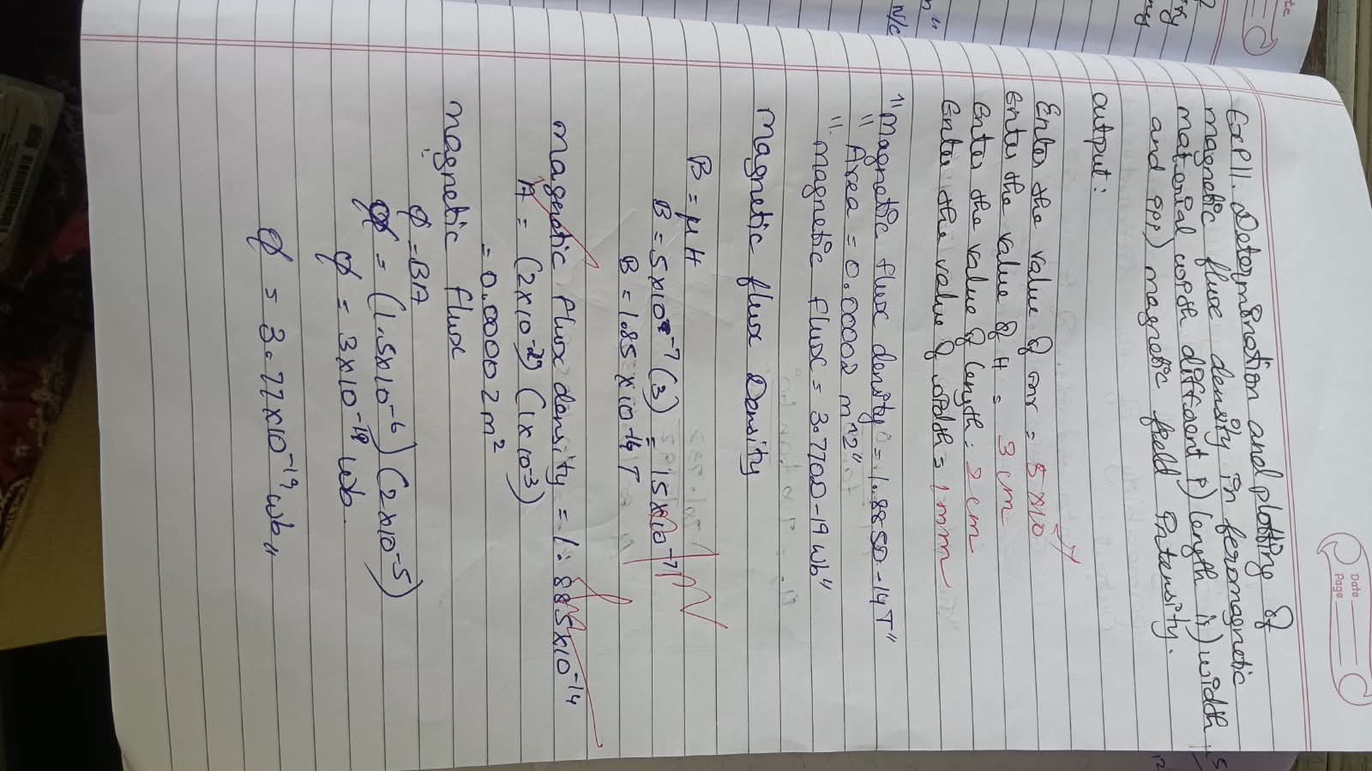
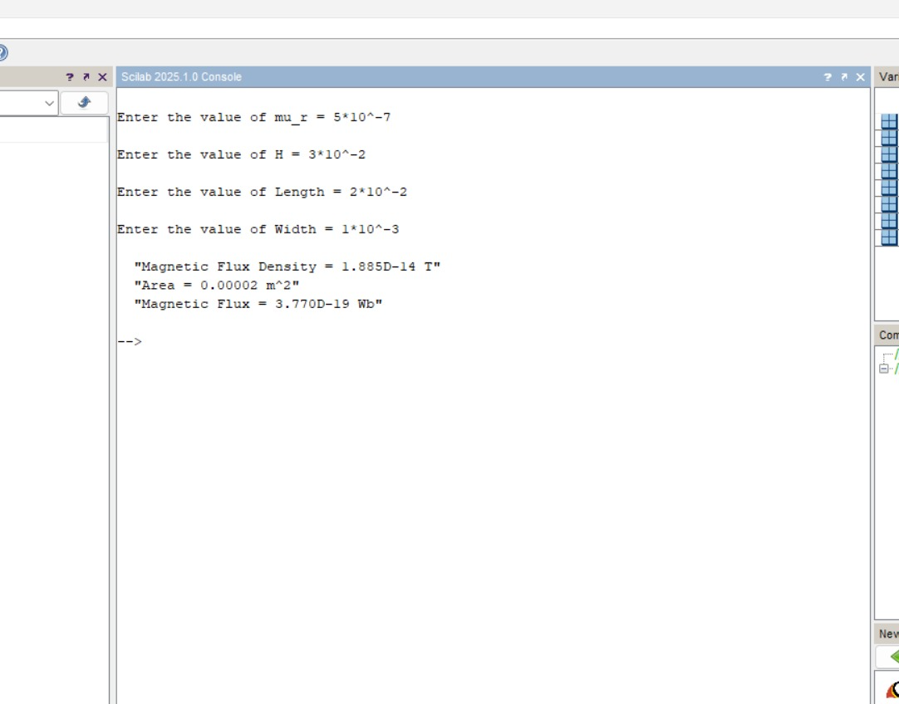
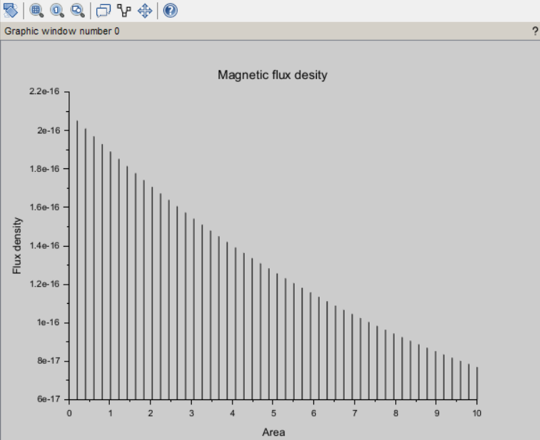
Result :
Thus the program was verified for program for Magnetic flux density in ferromagnetic materials using SCILAB was successfully.
Case 1: Examine the effect of length of a ferromagnetic material on the magnetic flux density (B).
Analytical :
Calculate the magnetic flux density for the following conditions
- The material is ferromagnetic with relative permeability (μr​) of 500.
- The magnetic field intensity (H) is held constant at 100 A/m.
- The length of the material varies from 0.1 m to 2 m.

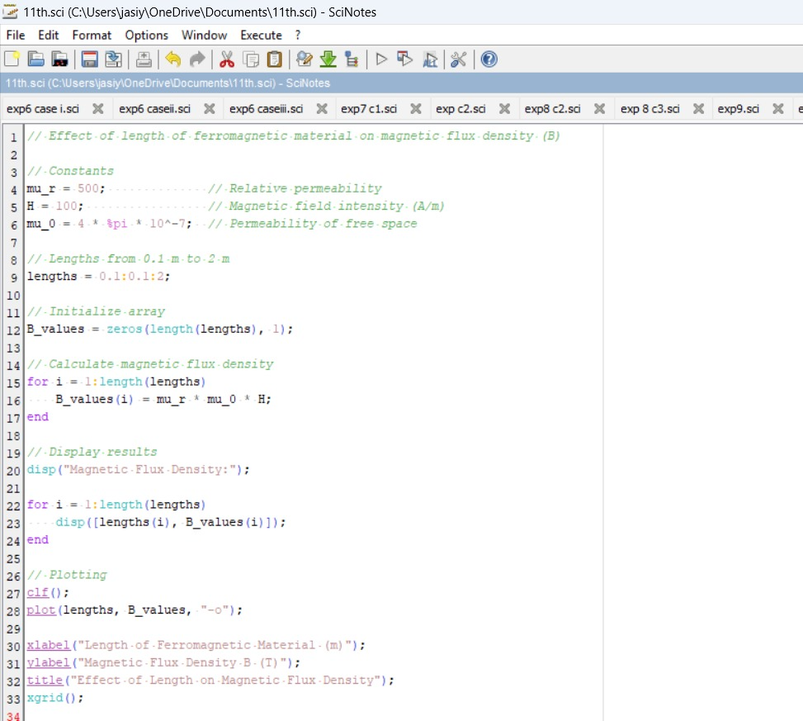
Code:

Output:
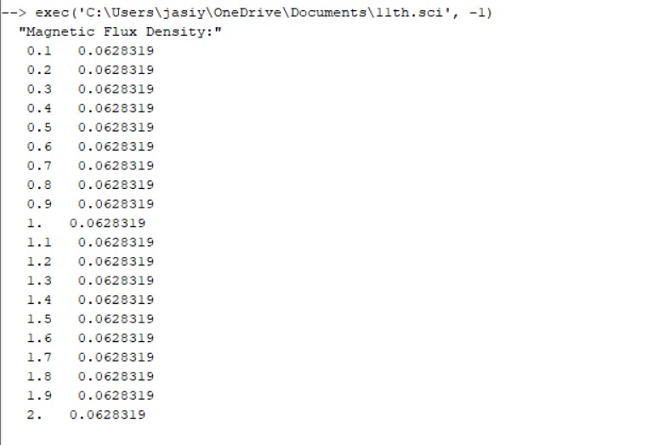

Graph:
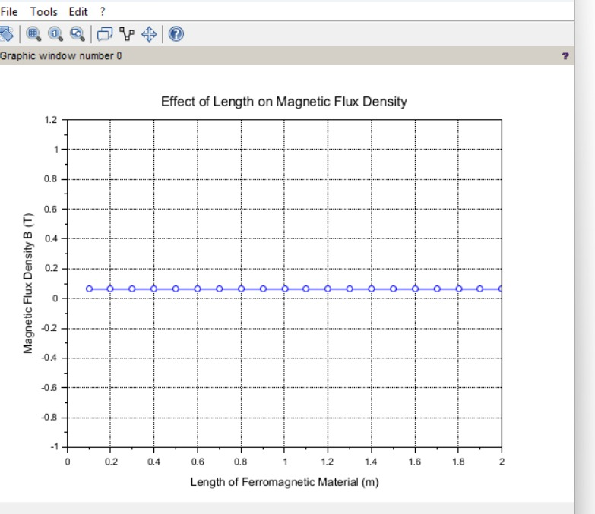
Case 2: To investigate how the magnetic flux density (B) in a ferromagnetic material changes with different widths at a constant length and magnetic field intensity.
Conditions:
- Material: Soft iron (same as in Case Study 1)
- Length (L): Constant at 10 cm
- Magnetic Field Intensity (H): Constant at 1000 A/m
- Width (W): Varies from 2 cm to 10 cm (i.e., 2 cm, 4 cm, 6 cm, 8 cm, 10 cm)
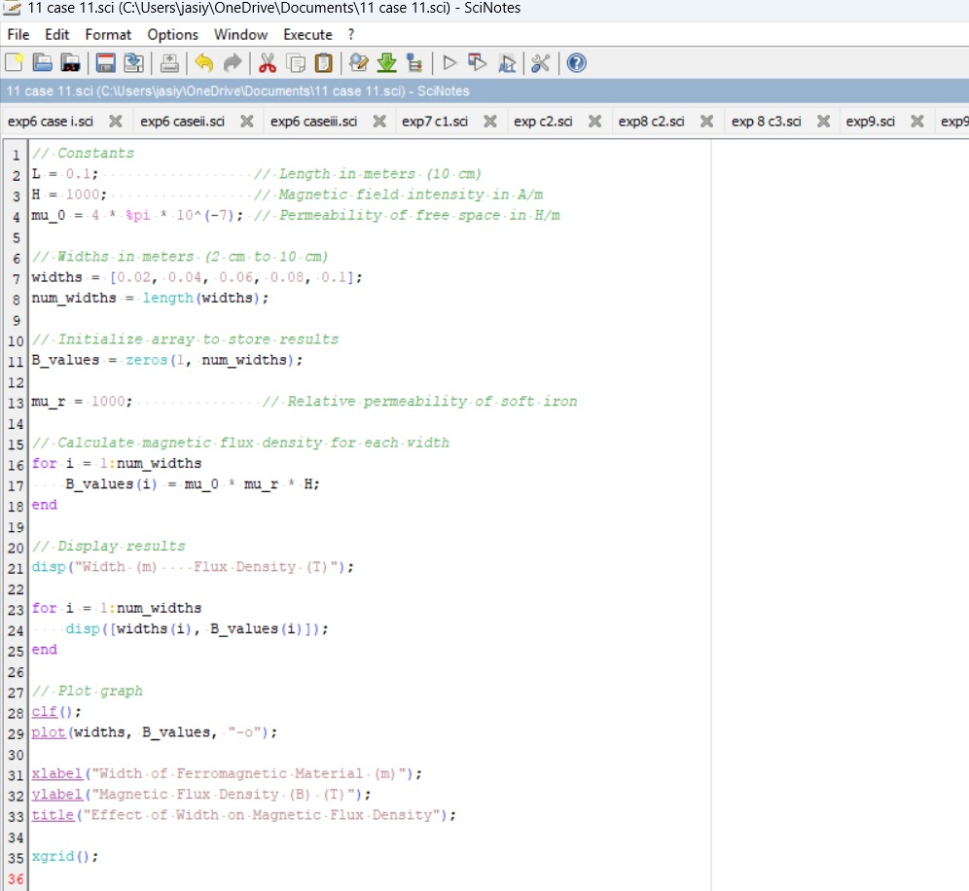
Output:
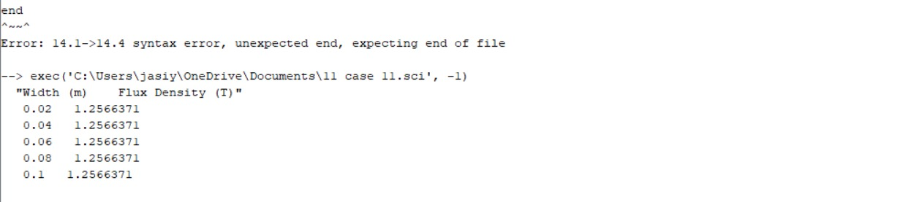
Case 3: To examine how the magnetic flux density (B) in a ferromagnetic material changes with different values of magnetic field intensity at constant length and width.
Conditions:
- Material: Soft iron (same as in the previous studies)
- Length (L): Constant at 10 cm
- Width (W): Constant at 5 cm
- Magnetic Field Intensity (H): Varies from 200 A/m to 2000 A/m (i.e., 200 A/m, 500 A/m, 1000 A/m, 1500 A/m, 2000 A/m)
Code:
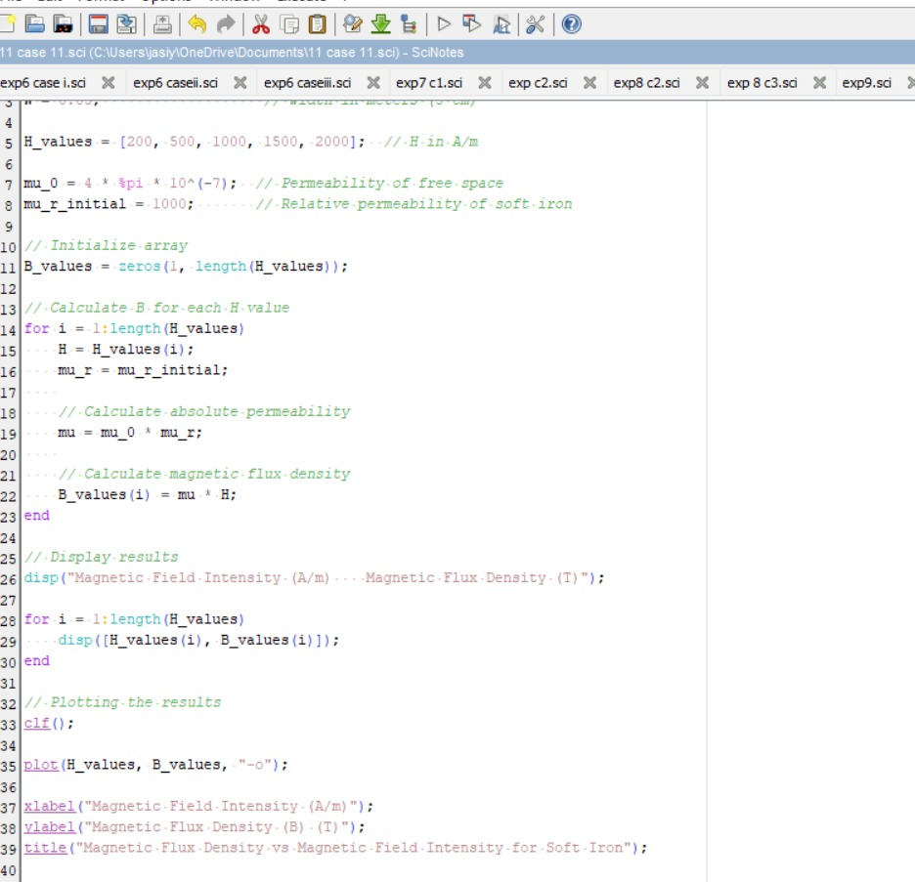

Output:
